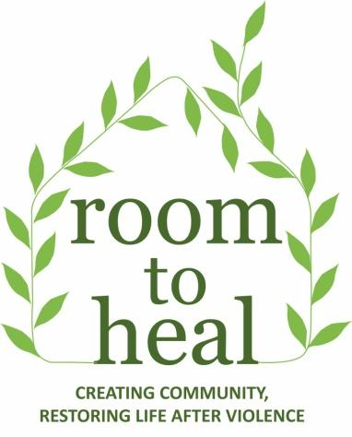

Room to Heal Annual Evaluation 2017
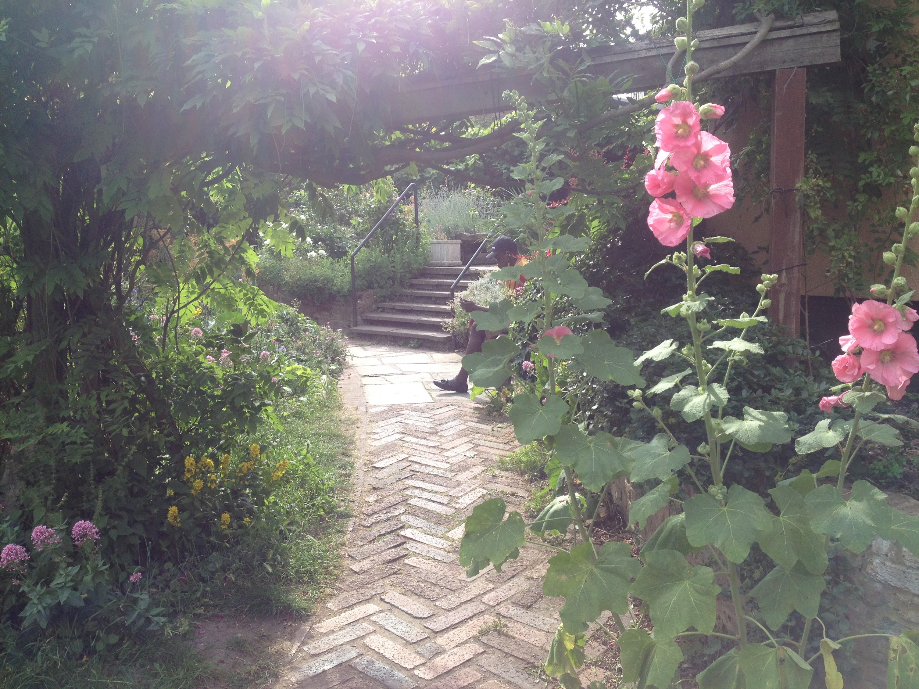

CONTENTS

1) BACKGROUND 2
2) KEY FINDINGS 3
3) SURVEY METHODOLOGY 4
4) PROFILE OF 2017 RESPONDENTS 6
5) SURVEY FINDINGS 7
6) DISCUSSION OF SURVEY FINDINGS 17
7) CONCLUSION AND RECOMMENDATIONS FOR PROGRAMME DEVELOPMENT 27
APPENDIX I: THERAPEUTIC GARDENING 29
APPENDIX II: CULPEPER GARDENING AND SOCIAL 31
APPENDIX III: COMMUNITY FORUM 33
APPENDIX IV: THERAPEUTIC RETREATS 34
APPENDIX VII: ACTIVITIES IN 2017 40

BACKGROUND

Room to Heal is a therapeutic charity supporting people who have survived torture and human rights abuses. At the heart of our work lies the cultivation of a healing community through which people can address the legacy of their traumatic experiences and rebuild their lives in exile. This is achieved through an integrated programme of therapeutic and practical casework assistance.
We offer a place of belonging, supporting people withstand the many challenges they face. Our members arrive alone, traumatised and unsure about the future. High levels of isolation and disenfranchisement associated with life in exile compound mental health problems and many of our members face homelessness and destitution. Furthermore, members face a convoluted asylum system noted for inconsistent rulings and high rates of detention and deportation. Therapeutic support, however effective, is not sufficient in itself to enable people to recover from the profound levels of trauma and dislocation, insecurity and material deprivation. Our holistic model takes into account the nuanced needs of each individual and provides a place safety and purpose, enabling people to restore trust, connection and integrate into UK society.
Each year we evaluate the impact of the work of RtH in order to inform our development and improve our services. The central part of this evaluation is our Annual Members’ Survey - through which members are able to reflect and share their views on how they have been affected by their membership of RtH. The evaluation process offers an opportunity to reflect on what is working and what is not working. This helps us to inform our programming and ensure that our activities have reflected our aims.
Having installed a new clinical database we are also including more information on outcomes measured through this system, throughout the year.
We use qualitative and quantitative data to try to build a well-rounded picture of RtH: monitor our projects and the effectiveness of our approach. We realise that numbers and percentages alone cannot capture the myriad ways in which members interact with RtH as an organisation, and so throughout the survey we aim to give members enough space to add additional comments where they see fit.
The Annual Members’ Questionnaire was compiled by Rae Ambarwati, Senior Community Support Worker and Isabella Mighetto, Evaluations and Outreach Consultant. Rae completed the quantitative analysis and Isabella the qualitative. The report was reviewed by staff and Trustees and shared with our members.

In 2017 we supported 105 survivors of torture and organised violence in varying capacities. Key outcomes included:
10 people resolved their immigration status thanks to our expert evidence;
26 people secured education through our pathways programme;
9 people secured benefits;
24 people secured grants;
17 people secured housing;
24 people were protected from destitution
24 people were supported to access medical care
59 people accessed training through workshops
10 people accessed photography and media training
34 people were assisted with legal casework (providing therapeutic letters etc)

KEY FINDINGS
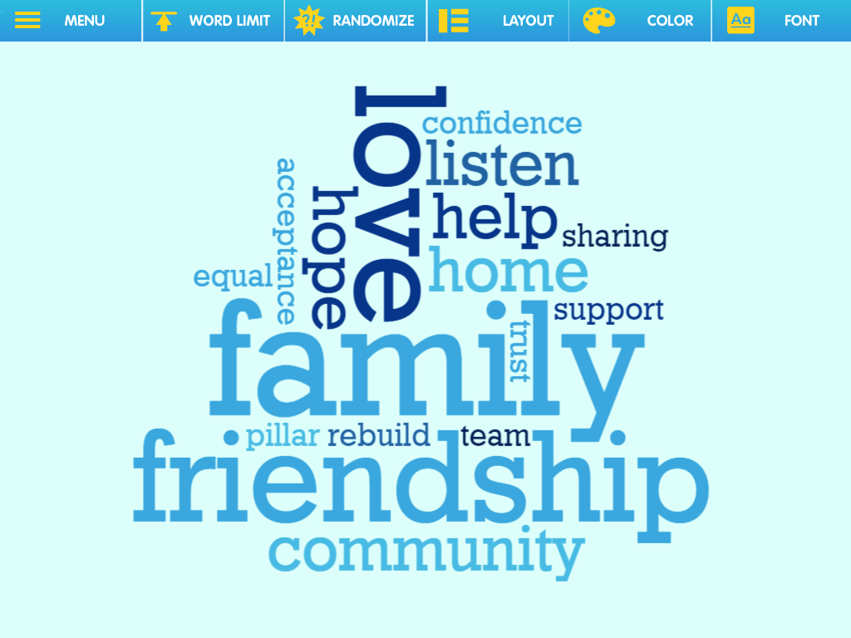
The results of this year's evaluation show, as in previous years, that it is the cumulative impact of the community-based, holistic programme which proves beneficial to members' sense of well-being and improved mental health, that facilitate the "family" of RtH. The questionnaire breaks down elements of our work and this evaluation shows how they play a specific part in improving someone's life.

Figure 1: Most frequent words used to describe RtH in the 2017 Annual Members’ Survey.

The 2017 members’ survey showed that:
95% felt more supported by other members of RtH
95% felt their confidence had improved
81% felt more able to engage positively with the opposite sex
95% felt more able to cope with the effects of trauma
94% felt better able to cope with the asylum process
93% felt more confident to communicate with a lawyer
80% felt better able to access financial support
83% felt more able to access housing
93% felt more able to access healthcare providers
88% were informed by RtH about places to study and receive training

This evaluation focuses on members of RtH’s perspectives on the impact of RtH’s work on their wellbeing. It breaks down elements of RtH’s work into constituent parts, shedding light on how different elements of our programme affect a person. It is clear, from our survey results, that each element has played a specific part in improving someone’s life, e.g. preventing homelessness, or easing trauma symptoms, but what comes across most strongly in our members’ feedback, as in previous years, is the sense of RtH as a family, a place of belonging and safety on which they can rely.

“Room to Heal is a very support centre and pillar for me. The wealth of information I get from members of staff: very useful. The community spirit is helpful for me.”

“Room to Heal means a lot to me because it has given hope and help to rebuild me mentally and given confidence in people. It also made me to have trust in people again.”

“It means a family that I have never had and always wished to have.”

“RtH means everything to me, means family for me, means friends for me, means the world for me. I love room to heal. Without RtH I would be nowhere.”

“RtH meant a lot for me, a team who is equally treated everyone. They are the people I can trust.”

“As those seeds we are planting for a new life also my life should be rebuild for a better future.”

SURVEY METHODOLOGY
The Annual Members’ Survey gathers data and feedback in order to assess performance against the outcomes we identified in relation to the above Theory of Change statement.
The questionnaire was compiled collaboratively, drawing on questions from previous years but this year we streamlined the questionnaire and amended phrasing to make it clearer and more comprehensible to members. A total of 21 members filled out the questionnaire. This is approximately 20% of the active membership of RtH. This represents a statistically significant sample. The majority of the sample was self-selected from those who regularly attend Tuesday therapeutic support groups. Since joining the therapeutic support group is a prerequisite for becoming a full and engaged member of the community, added to the survey validity.
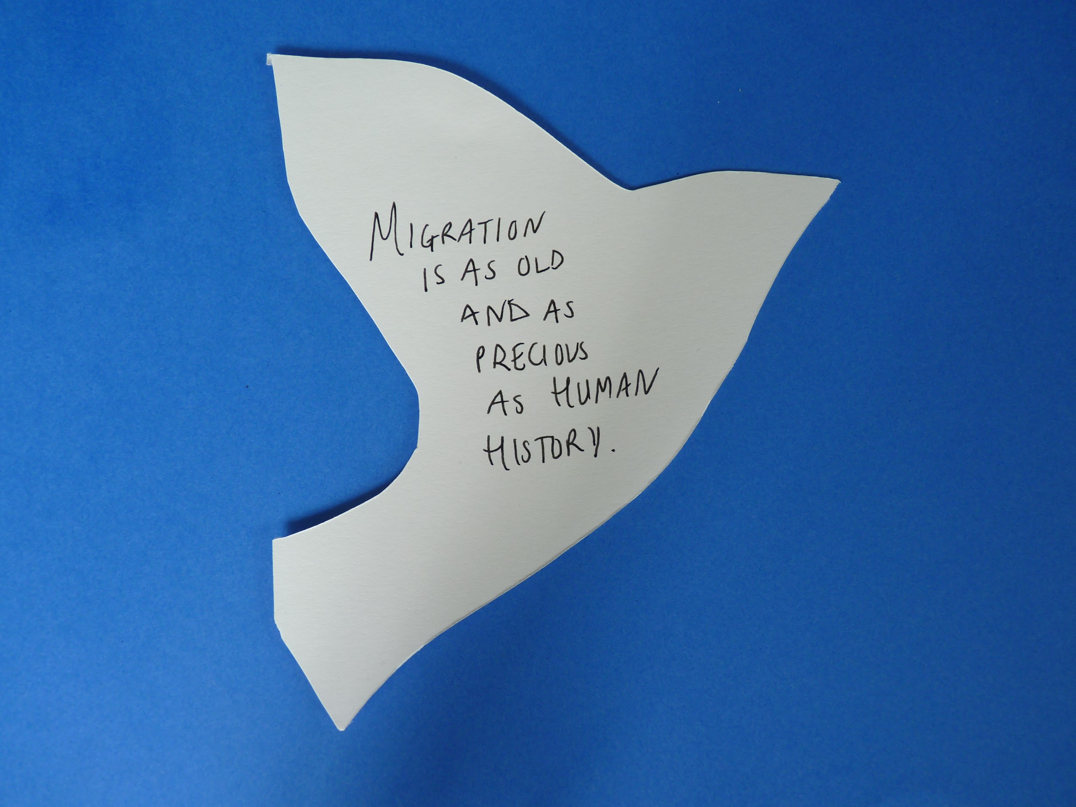
It was made clear to all respondents that the questionnaire was voluntary, that they could decide to stop completing the questionnaire at any point without explanation or consequence, that their comments could be given anonymously and that they could let us know if they would prefer us not to share their views.
Most respondents filled out the questionnaire on their own, during a quiet moment in the Culpeper garden on a Friday, or after lunch in the Community Centre group room on a Tuesday. Each respondent was given space and privacy, but also support or clarification if required. A member of staff went through the questions with those who have some challenges with written English, allowing the member to speak freely and transcribing the response onto the questionnaire.
Although some of the questionnaire contained ‘Yes/No’ answers, the responses were generally classified on a 4-point Likert scale of ‘Much better/ A little Better/ No Change/ Worse’ and often with the option of ‘This Doesn’t Apply to Me’. It is worth noting that percentages were calculated based on the number of people who answered the particular question; it excludes the number who stated ‘This does not apply to me.’
The fact that we administer the evaluation reports internally rather than appoint an external evaluator has some implications. This may introduce some level of bias (with members perhaps attempting to give more positive responses to be polite, or to please staff - “social desirability”/”demand characteristics”). However, the relationships members have with staff also mean they are able to trust and open up in a way they might not with external evaluators.
The process of compiling the evaluation report, of sifting through responses and choosing and shortening respondents’ more lengthy answers, introduces the subjective perspective of the person writing the report. Furthermore, ordering the survey responses in-line with RtH’s aims and outcomes is challenging, it means we have to categorise responses that transcend neat classification, and does not quite reflect the holistic, integrated approach of RtH or the way each output can produce any array of non-linear outcomes.

PROFILE OF 2017 RESPONDENTS

A total of 21 members filled out the questionnaire: 10 respondents were men and 11 were women, of mixed ages. 10 people had their status or Leave to Remain and 10 people are still in the process of claiming asylum or waiting for a decision. The length of time they waited for or have been waiting for their immigration status, and the length of their membership of RtH is outlined below:
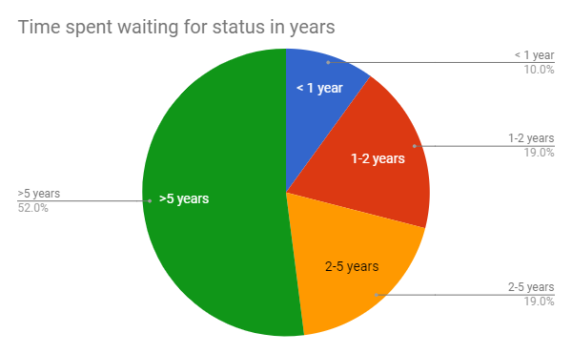

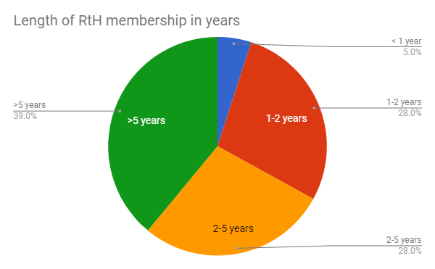

SURVEY FINDINGS
Aim 1: To enable people to heal from their traumatic experiences

Outcome 1: Instillation of hope and meaning in life

- 90% felt life was more meaningful as a result of coming to RtH [58% much more positive; 32% a little more positive; 5% no change; 0% less meaningful]
"Coming to Room to Heal made me to know that life could still be better and be myself again. Given me more hope."

- 86% felt more able to enjoy life [24% much more able; 62% a little more able; 5% no change; 10% not sure]

"I feel more able to enjoy life because I just have a positive decision with the help of room to heal. I find a new family in the name of room to heal."

"The negative decision on my asylum case made me depressed and not given me happiness."

- 81% felt their quality of life had improved [29% a lot; 52% a little;10 % no change; 5% worse]

"They been nice to me and changed my life a lot."

"My life is getting better after I start coming here."

"Changing my life, bring more information, learning about life."

- 95% felt more positive about the future as a result of being part of RtH [43% much more positive; 52% a little more positive; 0% no change]
"Before I started Room to Heal, things were very bad, now I believe things will be fine because I have a family here behind me."
"We started the fresh claim process. There is no change yet but we believe it will be ok."
"I take more interest in me and my life. I am more positive about my future."
"As those seeds we are planting for a new life also my life should be rebuild for a better future."

Outcome 2: Reduced isolation

- 90% felt less isolated [35% much less isolated; 55% a little less isolated; 10% not sure]
"There's very the uncertainty about the future however knowing that I am not the only one going through this process and actually meeting with them (fellow members) gives a little positive feel."
"I have made new friends."

"In the group I can see that I am not alone in the same situation."
- 95% felt more listened to [63% a lot more listened to; 32% a little more listened to; 0% no change; 0% less listened to]
"Room to Heal means a family, a community, a place where we are sharing our burden, is place where we are listened and helped"
"Room to heal mean a lot to me is a place where I feel confident, listen to, I feel love and most of all it is a new found family."

- 90% felt more supported [71% a lot more supported; 19% a little more supported; 0% no chance; 0% less supported]
"I still feel I need more help."
"Because I now that I have a family like room to heal we will always be there for me in good and bad time therefore I am not too scared of the future."
"RtH means everything to me, means family for me, means friends for me, means the world for me. I love room to heal. Without RtH I would be nowhere."
"Room to Heal is a very support centre and pillar for me. The wealth of information I get from members of staff: very useful. The community spirit is helpful for me."

- 95% felt more supported by other members of RtH [57% much more supported; 38% a little more supported; 5% no change; 0% less]
"They support me in every decisions I make."
"Room to Heal means a lot to me because it has given hope and help to rebuild me mentally and given confidence in people. It also made me to have trust in people again."
"We see each other and talk through our problems and advise each other. We are all friends."

- 90% felt more able to maintain relationships with others as a result of coming to RtH [40% much more able; 50% a little more able; 10% not sure]
"Being a member of Room to Heal help me socialise with people this can only improve with time."

Outcome 3: Development of trust and a sense of belonging

- 95% felt their confidence had improved [35% felt much more confident; 60% a little more confident; 0% no change; 0% less confident]
"It has give me more confidence to express myself. It has also prepared me to face the question [in asylum interview]."
"Because I am able to do things that I have never done before."
"I can even scream about things, laughing, I'm free to talk and to say things."
"If something happened to me, I would first contact this place. Before I was very scared about everything. Now I feel relaxed as if something happens I know Room to Heal are there. Before when I saw police I would turn away, now I walk past them."

- 80% felt more connected with other people (e.g. family, friends, neighbours, classmates) [45% much more connected; 35% a little more connected; 10% no change; 5% less connected]

"I am part of community and if I am not there, I will be missed."

"When you are in the community, you feel like you have friends and that you have family."

"RtH meant a lot for me, a team who is equally treated everyone. They are the people I can trust."

- 81% felt more able to engage sensitively with the opposite sex as a result of coming to RtH [43% a lot more able; 38% a little more able; 5% no change;5% less able]
- 100% felt RtH had made them feel part of a wider community [68% very much; 32% a little; 0% no change; 0% not at all]
"I feel now I am also part of London."
"I am in the community, but they can, I mean Home Office can take me away."
"Because room to heal help me widen my life through room to heal i feel a part of London."

- 74% felt they could participate in RtH decision-making [42% a lot; 16% often; 16% sometimes; 5% not much; 11% not at all; 11% not sure]

"It is a time to influence decision is have our say in how we things should be directed."

"The community forum is the place where you can talk about what you want to see happen."

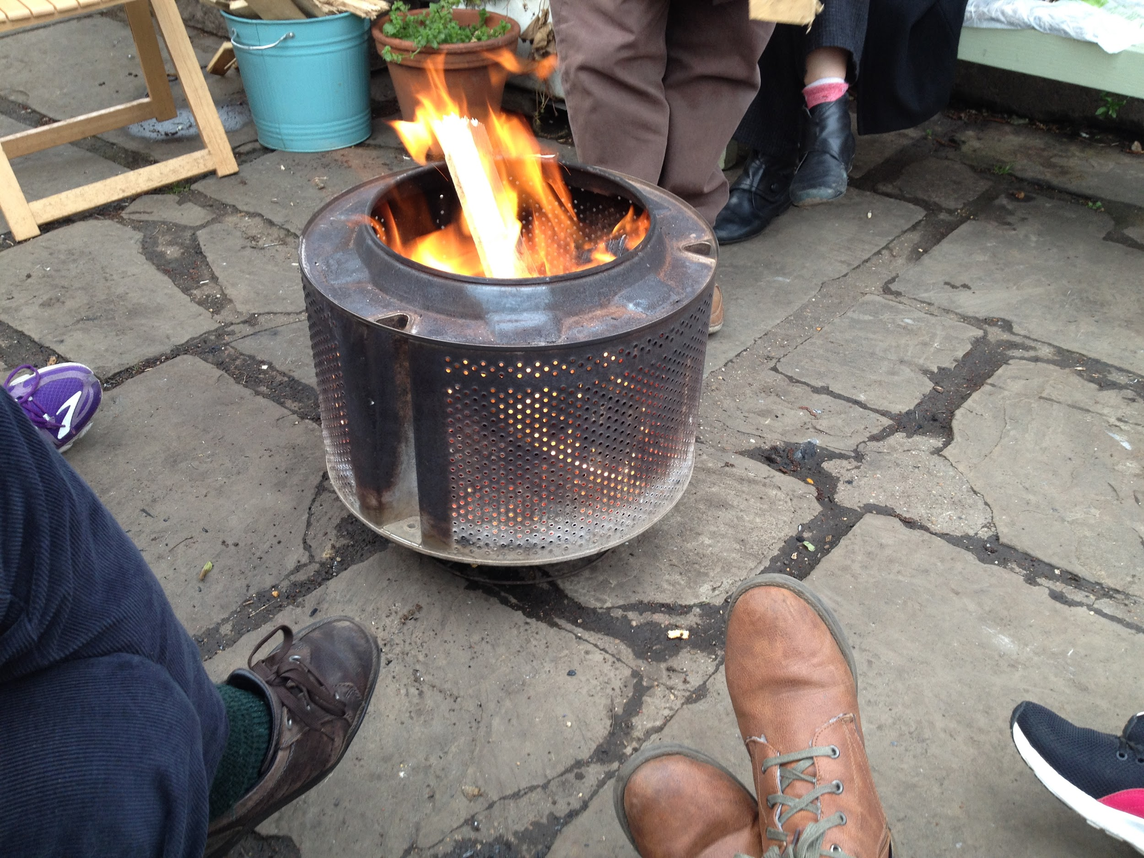
Outcome 4: Reduction of anxiety, depression and related post-traumatic symptoms

- 100% reported improvement in mental health [67% much better; 33% a little better; 0% worse; 0% no change]

"It makes me feel much better for mental and body physical. I feel more happy, I don't think of anything else."

"It's a beautiful place when you're stressed or when you're feeling down. Activities help me a lot because we all work as a team."

- 85% reported improvements in physical health [33% much better; 52% a little better; 0% worse; 0% no change]

"I feel more relax[ed], more able to do some physical activities. I feel less down physically as I am focusing in something stimulating my being."

"I have asthma and I like the fresh air. It feels good."

"I eat better in general and I have great people helping me out."

- 95% felt more able to cope with the effects of trauma [38% much more able; 57% a little more able; 0% less able; 5% this doesn’t apply to me]
- 76% felt the symptoms such as flashbacks, sleeplessness, panic attacks had got better [14% much better; 62% a little better; 14% no change; 5% worse, 5% not sure]
"I am more calmer. I am able to manage my stress and anxiety better."

Outcome 5: Increased ability to articulate traumatic history

- 91% felt more able to talk about the traumatic, painful things that had happened to them [29% much more able; 62% a little more; 0% no change; 0% less able]
INDIVIDUAL THERAPY
100% found individual therapy helpful
"It's good to talk individually when I am feeling down emotionally."
"In the way helpful, in the same time I prefer to be more in the group so I can see that I am not alone in the same situation."
"It is very good because you can sometimes share with the therapist what you don't feel confident sharing in the group."
"Share your pain in detail and you know someone is listening with full care and confidential."
"Individual therapy personally allowed or say gave me the opportunity to just be 'Me'. It was personal. Very helpful- personal option really."
"I wish there was a longer period of one-on-one sessions as opposed to the 12 sessions available at the moment. I am however very thankful I got the sessions to start with."
GROUP THERAPY
100% found Group Therapy helpful:
"The therapeutic group had given me confidence to open up in life. Most importantly my mental health I really improve."
"I am happier than before."
"I feel more safe this is changes me a lot. I more consider everyone as part of my family with who I can talk about difficult moment."
"Putting support group in my timetable has been helpful for me even before sharing."
"We see each other and talk through our problems and advise each other. We are all friends."
"It's helpful because it gives boldness and gives me opportunity to speak out and to have trust in people again."
"I love the group support, and I love eating together and Tuesday is my family get together.

Aim 2: To assist people in dealing with material challenges

Outcome 1: Increased knowledge of and ability to access/ receive support from relevant services (legal, welfare, housing, health)

LEGAL
- 93% felt more confident to communicate with their lawyer about their case, or to find a good lawyer if they didn’t have one [50% lot more confident; 20% a little more confident; 5% no change; 0% less confident; 25% this doesn’t apply to me]
"Room to Heal helped me get Legal Aid which has been very helpful and continues to be helpful. I however believe I am confident communicating with my lawyer. I am thankful for the help received getting a solicitor to take on my case."
"Iman has supported me with this and pushed the solicitor. I waited 2 years for psychiatric report. I communicate with my solicitor."
"I didn't have a lawyer. They referred me for immigration and gave support that someone came with me to accompany."
"They helped me to find a good solicitor who win my claim with home office. Its really thoughtful to them."

WELFARE
- 80% felt the support and information from RtH helped them access financial support (benefits, cash, vouchers) [80% said it had helped them; 15% said it had not helped them; 5% said they were not sure]
"First I am so grateful that financial support is there. This make a big difference so I could buy things I need."
"They help me to get a grant for a baker course and for a lot of other things."
"Although we are facing difficult situation, time to get support than years before, Room to Heal help to get around £200 this year."

HOUSING
- 83% felt more able to access housing if they needed support with this [48% a lot more able; 0% a little more able; 10% no change; 0% less able; 42% this doesn’t apply to me]
"They helped with the housing benefit, housing, to call them, and find me a lawyer for housing."
"They helped me to find a place to live and also to feel valued. I think everyone need a place where you feel secure."
"I was homeless, through them I got a place with a host."
"They stopped my housing [from] kick me out"
HEALTH
- 93% felt that the support and information from RtH made them feel more able to access healthcare providers (GP, Doctors of the World drop-in clinics, NHS etc) if they needed support with this [30% a lot more; 35% a little more; 5% no change; 30% this doesn’t apply to me]
"I feel confident to go to the GP."
"Room to Heal help me to get HC2 and call a doctor."
"I did not have HC2 certificates. I now have one for GP and dentist."
"Yes, they helped me to renew my HC2 certificate, and help me to get proper treatment for my mental health from the GP."
“I had GP before access Room to Heal.” / “I have a GP already”.

Outcome 2: Increased awareness of rights and entitlements

- 79% felt more aware of their rights and entitlements [68% a lot more aware; 11% a little more aware; 11% felt their awareness had not increased; 11% said it did not apply to them]

- 62% felt RtH had helped them access other specialist services and/or organisations (for example Red Cross, Refugee Council, Migrant Centres) if relevant [40% said they had been helped; 25% said they had not; 35% said it didn’t apply to them]

Outcome 3: Increased confidence navigating asylum system

- For those going through the asylum process, 94% felt better able to cope with the asylum process [68% a lot; 11% a little; 5% no change; 0% less able; 16% this doesn’t apply to me]
"I feel secure that they when with me to sign in Home Office. I feel calm to go with someone."
"Information-knowing about Home Office, changes, how to connect with the community, provisions such as NAS etc, has made dealing with the asylum process easier. Support- therapy programmes, getting me a legal rep. very very helpful indeed."
"They brought my case forward, improved it very well, helped with new lawyer, casework, grants, hosting (accommodation), letter writing."

Outcome 4: Greater knowledge of and ability to access education, voluntary work and employment training

- 88% were informed by RtH about places to study and receive training [70% were informed; 10% were not; 20% said it did not apply to them ]
"Room to heal helped me to go to college and advising me what I need to do."
"I found a good course to study because of the help from Room to Heal."

- 56% were helped to access education and training [45% were helped; 35% were not; 20% said it did not apply to them]
"I wanted to go university unfortunately we could not get the funding"
"The training was organised but seemed to lack space, no-one was chosen in Room to Heal"
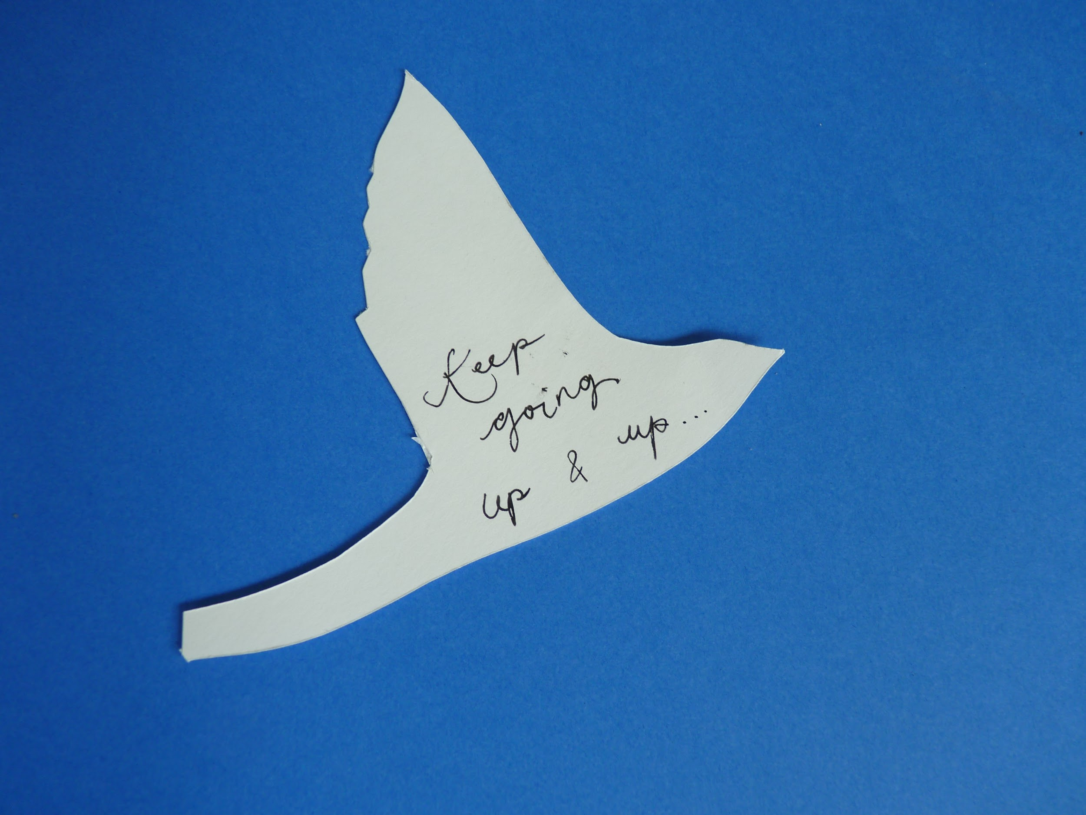
"Their propose to me but I wasn't feeling ready to do it. Now if I get the opportunity again I will do it."
"It help me find an english course which is very good for me."

Aim 3: To improve the care of torture survivors

Outcome 1: Local communities, policy makers, mainstream service providers and the general public have a greater understanding of the needs of survivors of torture and organised violence

- 60% of respondents felt more confident to share their experiences as an asylum seeker or refugee with wider society (for example to educate or to raise awareness) [20% much more confident; 40% a little more confident; 10% no change; 10% less confident; 20% not sure]

"Of course, a refugee or asylum seeker...am unknown life by people from the country, by those making decisions who has the power to bring light."
"Helped me to express my view"
"I am given a voice."
"Because I been sharing in the group support so I gain more confident."
"I don't like to talk about it with anyone."
"But I am very shy"
"They need to know that there are asylum seekers in the world like me. I was in the dark, crying alone."
"I am unsure I would really like to share my experiences as an asylum seeker with a wider society as yet. There's a good possibility I would once I am done with all of this and of course with a positive outcome."
- Our new participatory photographic project with the artist Nadia Bettega (Eyes Wide Open) is involving members in an inclusive and instructive way to express themselves through photography. We are hoping to show the photographs at venues around London and the UK, to challenge perceptions and humanise the debate on migration. It is a powerful way for members to dictate how much of themselves they wish to reveal or allude to through the camera, and feedback from members has been very positive so far: “I am given a voice.”

Outcome 2: Policy and practice are better suited to meeting the needs of survivors of torture and organised violence

We have achieved a great deal of positive feedback as a result of outreach work and partnerships, which we have put a lot of energy into developing over 2017.
- At the UN Fund for Victims of Torture Annual Expert Workshop in Geneva we shared our unique community-based approach to rehabilitation with 42 frontline workers and over 30 state representatives. Requests for training and consultancy came from numerous organisations working internationally in challenging contexts.

- Mark Fish facilitated two training workshops in Tunis with mental health professionals, alongside a psychologist from OMCT (World Organisation Against Torture). He also facilitated an experiential group training with psychologists, social workers and pastors in The Gambia (see Appendix V):
100% said they would be able to use the training methodology in their work
100% said the training met their professional/personal needs:
“We became more able to understand the mechanisms of how to facilitate the listening groups which will help us to develop services for victims of torture and abuse, in order to assist them in overcoming the sequelae of torture.”
- In 2017 our casework team has attended 15 training and evidence-based sharing meetings with a total of 449 people.

- Our therapists attended 4 Refugee Therapist Practitioners Forums to share knowledge and insights.

DISCUSSION OF SURVEY FINDINGS
Aim 1: To enable people to heal from their traumatic experiences

Therapeutic group activities enable us to build the strong, authentic community that lies at the heart of RtH and support each member through the myriad challenges they face. 100% of respondents found the support group helpful, and 100% found individual therapy helpful. But what is clear is that it is the interaction of activities, the community, the range of social activities and practical casework support which help RtH achieve this aim, facilitating healing, however long this may take.

Outcome 1: Instillation of hope and meaning in life

"I know that I important in the society, I have a family at Room to Heal who can stand for me. That I am loved"
- 90% felt that life was more meaningful
- 95% felt more positive about the future

As Helen Bamber said, torture “is a perversion of all that is good in human relationships”, and not only in human relationships but in existence in its totality. Bendfeldt-Zachrisson describes torture as a “catastrophic existential event.” Survivors, by their very survival, are coming to terms with existence in a world in which everything that makes them human has been used to cause them pain. The existential dilemma of the survivor “may be the dominant feature and may be the most difficult for the person to overcome.” Many of our members experience this as a profound hopelessness and loss of direction. Turner & Gorst-Unsworth state that one of the most difficult tasks in the recovery process for torture survivors is “not the control of evident symptoms but the rebuilding of their shattered sense of self”.

At RtH, we take an expansive definition of healing as a starting point: refusing to pathologise or to medicalise distress, but instead to see pain as a consequence of traumatic lived experiences and situate its psychological and physiological ramifications.

When hope is not forthcoming from within, the validation and unconditional non-judgemental acceptance from our staff and from fellow members gives the necessary boost to enable the realization that things can get better. With this come greater feelings of self-worth: "I am part of community and if I am not there, I will be missed"

Outcome 2: Reduced isolation

"Before I started Room to Heal, things were very bad, now I believe things will be fine because I have a family here behind me."

As in last year's Members' Survey and those of previous years, the idea of RtH being a second or a new ‘family’ was strong: When asked to summarize what RtH meant to them at the end of the questionnaire, 50% referred to RtH as a ‘family’.

Often living in destitution, alone or in crowded but alienating NASS (asylum) accommodation, and with frequent negative and long-winded encounters with the Home Office/solicitors/welfare providers, structurally welcoming support networks are often non-existent and people report feeling lonely and disenfranchised. Added to the structural injustices people face, severe and enduring mental health problems can make people feel alone and isolated.

But just as “dehumanization inherent in torture attacks the refugee's usual sense of personhood, of social bonds, and of values, causing him or her instead to feel acutely isolated and vulnerable,”healing, the inverse, involves nurturing and rebuilding these human bonds. Turner and Gorst-Unsworth state “Survivors of torture may gain the greatest support from each other.” Through engaging in the therapeutic support group alongside others who have this common experience (not only with regards to a traumatic past, but also related to present challenges of being an asylum seeker in London), people begin to realise that they are not in fact alone, as one member wrote: "In the group I can see that I am not alone in the same situation."

Members refer to the benefits of socialising at Culpeper Community Garden (I can spend time with other peoples that accept me as who I am.” / “I like to sit around fire. Chatting and realise I have friends and some social life.”), the teamwork of therapeutic gardening (“I feel like this is my family”). This mutual support can reduce isolation extending beyond the space of RtH: "We see each other and talk through our problems and advise each other. We are all friends," as people feel that they have more confidence to build relationships and feel more part of the wider community.
Outcome 3: Development of trust and a sense of belonging

“Room to Heal means a lot to me because it has given hope and help to rebuild me mentally and given confidence in people. It also made me to have trust in people again.”
When trust has been shattered through torture and human rights abuse and when members have faced discrimination in the UK as well as in some cases, detention in immigration removal centres, it is common to be suspicious of people.

For people whose past traumatic experiences involved gender-based persecution, there can be significant fear of the opposite sex. Since 2015, when we initiated the mixed-gender support groups, our members’ self-reported levels of ability to engage with the opposite sex has increased steadily. In 2015, 74% reported being more able to engage sensitively with the opposite sex, in 2016, 77% felt more able, and this year, 81%.

100% felt RtH had made them feel part of a wider community.

The overarching feeling of being part of a community translates into everything else.“[In a] therapeutic community […] the community itself, through self-help and mutual support, is the principal means for promoting personal change.” Through reaching out to others, being signposted to other organisations, trainings, events, spaces, people can rebuild a sense of self and realise that there are things that they can become involved in: "Room to heal help me widen my life [...] I feel a part of London."

However, for members in limbo, without immigration status, insecurity is much more apparent: The fear, anxiety, frustration and disappointment provoked by having uncertain status takes a toll on a person's emotional resilience:
"I am in the community, but they can, I mean Home Office can take me away."
"Until I have right to stay I have worrying always"
The omnipresent threat of detention and deportation to the place of danger is fear-provoking and its magnitude cannot be underestimated. What can be read from members’ responses is that the consistent presence (“pillar”, “home”, “safety”) of RtH reduces disproportionate fear and panic, and although there is of course only so much that RtH can do to support people when faced with a hostile political environment, it has to be acknowledged how meaningful belonging to the community is for people:
"If something happened to me, I would first contact this place. Before I was very scared about everything. Now I feel relaxed as if something happens I know Room to Heal are there. Before when I saw police I would turn away, now I walk past them."

Outcome 4: Reduction of anxiety, depression and related post-traumatic symptoms

- 100% felt their mental health had improved:
- 85% reported improvements in physical health as a result of being part of RtH.
Trauma is not just an event that took place in a distant past: it is the imprint of that experience on mind, brain and body. This is why RtH sees each individual as a complex, multifaceted being, acknowledging, validating and bearing witness to the lived experience of people’s trauma.

"It's a beautiful place when you're stressed or when you're feeling down. Activities help me a lot because we all work as a team."

"I am calmer. I am able to manage my stress and anxiety better.”

Outcome 5: Increased ability to articulate traumatic history

Trauma is pre-verbal and whilst people’s bodies may vividly re-experience terror, rage, powerlessness etc, these sensations may be impossible to articulate. Trauma drives us to very edges of comprehension.

· “For to define trauma as simply that which comes from outside, rather than as a possibility inscribed within experience, would be, essentially, to make a claim for the possibility of defining, and thus anticipating, the difference between experience and trauma: to be able to categorize, to name, and thus, theoretically, to anticipate the accident.”

However, the unconditional environment of trust creates an empowering space where members can begin to take their narrative back into their own hands: "It's good to talk to someone about your problems." Being able to talk openly, be listened to, related to, and understood: taken seriously and validated as a human being is experienced as deeply healing.

"The new story that emerges is no longer a story about powerlessness—about losing the world and being totally dominated by someone else's reality [….] no longer about shame and humiliation—it becomes a story about human dignity and virtue."
However, it takes time to build trust and to feel comfortable to share inner pain to other people. One member expressed that this is much easier during one-to-one therapy: "It is very good because you can sometimes share with the therapist what you don't feel confident sharing in the group." But another member acknowledged: "In the way helpful, in the same time I prefer to be more in the group so I can see that I am not alone in the same situation."

Aim 2: To assist people in dealing with material challenges
Our therapeutic and casework team is continually learning how to deal with these challenges, so that we can support our members through tough political times. Legal protection work continues to be at the heart of our vital casework services: while our members face the constant threat of forced return to the countries from which they fled, are forbidden from working and isolated from mainstream society, meaningful recovery from trauma is limited. Our casework and therapeutic teams thus work hand-in-hand, spending considerable energy on this dimension of our work: ensuring members access high-quality immigration advice and representation, helping them articulate their traumatic narratives of persecution, providing therapeutic reports and letters to document our observations in relation to asylum proceedings.
Although separate aims, Aim 1 and Aim 2 are of course linked. All too often, trauma discourse around forced migration “focuses on high-impact events that occurred in the pre-migration environment. One of the dangers of this focus is that is overshadows basic needs in the present lives of resettled refugees.” As Freedom from Torture state:

“Sleeping rough, sharing a room with a potentially violent stranger, constant changes in accommodation, not having enough money for a nutritious diet or to buy essential toiletries will all prevent the survivor from feeling safe and hence being able to make best use of the therapy.”

Our work is impacted by the hostile environment, summed up by Immigration Barrister and author of Free Movement blog, Colin Yeo:

"The defining feature of the new hostile environment is the abandonment of the pretence at central government enforcement of immigration laws and the move to reliance on indirect means to encourage compliance with and punish breaches of immigration control."

Outcome 1: Increased knowledge of and ability to access/ receive support from relevant services (legal, welfare, housing, health)

“I didn't have a lawyer. They referred me for immigration and gave support that someone came with me to accompany.”

Often, our members’ most pressing needs centre around gaining legal protection. Our caseworkers may have to find members a lawyer (rendered challenging by the shortage of high-quality legal advice since Legal Aid Cuts and due to reputable law firms being at capacity) or communicated with that lawyer to further their asylum case. Members appreciate that this is not straightforward and that it takes a long time: "Iman has supported me with this and pushed the solicitor. I waited 2 years for psychiatric report.” Over 2017, RtH therapists wrote 15 therapeutic reports to provide evidence for people’s asylum cases. 10 members gained status over 2017.

A number of our members have faced street homelessness this year (many of them facing this more than once in the year) and as a result we have spent a considerable amount of time partnering with Positive Action in Housing ‘Room for Refugees’ Project. We have prevented our members becoming homeless 29 times this year.

Over 2017, our casework team supported 24 people to gain financial support, through £3424 in destitution/small educational grants Colleges which previously funded asylum seekers’ further education are now no longer offering free courses to those without refugee status. This has impacted the way we work, in that where it used to be a case of supporting members to apply for college, we now have to seek funding through grants, which is not always successful due to the limited pool of funding for education for asylum seekers.
With regard to healthcare, 93% felt that the support and information from RtH made them feel a lot more able to access healthcare providers. For those who answered no change, it tended to be more because they were already set up in the healthcare domain: “I had GP before access Room to Heal.” / “I have a GP already”.

Outcome 2: Increased awareness of rights and entitlements

Integral to having an increased awareness of rights and entitlements is the feeling that you are a person worth having rights and that you are entitled to support and to live in dignity. This feeling of self-worth is something that grows over the course of the therapeutic process. For many members who are worn down by the endlessness of Home Office bureaucracy, applying for any grants or benefits to which they are entitled, represents a considerable challenge and a deep sense of fatigue. Often, merely being able to share this frustration and impatience with someone is really helpful, and members are encouraged to make phone calls and fill out forms on their own, but with the knowledge that that they are not on their own in the process. This is a powerful way of combating the sense of alienation that comes with being a destitute asylum seeker navigating one's way through confusing systems.

Outcome 3: Increased confidence navigating asylum system

One of the key facets of casework at RtH relates to explaining processes and services and demystifying the labyrinthine asylum process. Beginning to understand something that has been designed to be incomprehensible is empowering, and with greater awareness comes an increased confidence. 94% felt better able to cope with the asylum process. As above, reducing isolation and actively supporting people with the process increases confidence:

“Information-knowing about Home Office, changes, how to connect with the community, provisions such as NAS etc, has made dealing with the asylum process easier. Support- therapy programmes, getting me a legal rep. very very helpful indeed."

Outcome 4: Greater knowledge of and ability to access education, voluntary work and employment training

We have been developing our ‘pathways project’ supporting 26 of our members into education, training and to access sustainable employment. We have built partnerships with a number of social enterprises and charities with a focus on training, education and employment (such as Luminary Bakery, Bread and Rose, RISE, Royal African Society, Code Your Future).

There are huge barriers to accessing education when you do not have refugee status: “Being an asylum seeker I do not seem to fit into most study programmes.” We realise that it is getting harder and harder to find funding opportunities for members who are asylum seekers, not all places are suitable for our members and not all places will, for example, reimburse travel expenses:
Like in previous years, there seem to be so many other pressing practical concerns, notwithstanding the fact that the therapeutic process takes a lot of energy. For members with severe post-traumatic symptoms, the inability to concentrate, high levels of tiredness and severe depression, anxiety as well as intrusive flashbacks, are all obstacles for feeling ready to engage in a challenging new course, or to committing to something for a long time. Often it is once people gain their status that they feel ready to engage in this process.
We are incredibly proud of RtH member Ahmed who received a Masters in Music Technology. RtH helped him gain a scholarship and have supported him for the last seven years. He recently got his refugee status.

Aim 3: To improve the care of torture survivors

We have learnt an extraordinary amount over the past ten years of being a specialist therapeutic community for survivors of torture and organised violence and believe we are now in a position to share our expertise so that other torture survivors can be better supported more widely, both on a national and international scale.

Outcome 1: Local communities, policy makers, mainstream service providers and the general public have a greater understanding of the needs of survivors of torture and organised violence

Being invited to the speak at the UN was of course a sign of our growing reputation. Increased activity on social media (twitter, facebook and the newsletter), has also increased the number of people we reach, and our short film was widely circulated, as well as coverage of Room to Heal by the UNHCR.

We are hoping to this coming year to work more with members in ‘speaking out’, taking inspiration from Survivors Speak OUT at Freedom from Torture, as it is clear just how vital (and sadly, often missing or overlooked) the voices of ‘experts by experience’ are in mainstream, dominant discourses on migration.

60% of respondents in this year’s survey said they felt confident to share their experiences as an asylum seeker or refugee with wider society (for example to educate or to raise awareness). For those who felt they had the opportunity, and would wish to take it up, it was very much linked to having a “voice” in the community, which provided the necessary step to go on and speak out beyond RtH: "I am given a voice" and "Because I been sharing in the group support so I gain more confident."

It is important to recognise that speaking out is not for everyone and not everyone will feel comfortable sharing their experiences outside the confidential, trusting and safe space of the support group: "I am very shy" said one member, and another:
"I am unsure I would really like to share my experiences as an asylum seeker with a wider society as yet. There's a good possibility I would once I am done with all of this and of course with a positive outcome."
For people struggling with the asylum system and the cumulative impact of destitution, precariousness and mental health difficulties, this may not be their top priority straight away, but it is a process and clearly those who feel ready have already got a lot out of projects such as the participatory photography project with Eyes Wide Open which is extending into 2018.

Outcome 2: Policy and practice are better suited to meet the needs of survivors of torture and organised violence.

We have put a lot of energy into outreach over 2017, from multi-agency casework meetings and forums to requests for training from international organisations working with migrants and torture survivors following our attendance at the UN for the Expert Workshop on Torture Victims in the Context of Migration (see video on Room to Heal website) and key aspects of our model were incorporated into UN best practice guidelines. Mark facilitated experiential training in working with survivors of torture, in The Gambia and in Tunisia. In the latter, RtHl partnered with the World Organisation Against Torture (OMCT) and delivered trainings to psychologists working with torture survivors from OMCT regional offices and the Tunisian Ministries of Social Affairs and Justice.
The meetings and outreach work here in the UK have enabled us to build on our existing partnerships with other organisations and stay up-to-date on issues affecting our members. It has given us a chance to voice our concerns directly with policy makers (especially in terms of asylum support) and to work with other organisations to discuss how best to support our members in light of negative changes as a result of the Immigration Act 2016. One such example is contributing evidence to Judicial Review proceedings launched by Liberty against NHS data-sharing with the Home Office for immigration enforcement.
We were invited to Norfolk to give guidance to organisations looking to set up therapeutic support for torture survivors in the region. We have also been developing partnerships with organisations in Devon to share our model and learning as there is a lack of specialist therapeutic and integrated care available. In this context, a key theme and challenge of the year has been determining the best way to increase the impact of our work, through extending our advocacy work and sharing our model and learning with other organisations, nationally and internationally.

We are developing a ‘speak out’ project in this vein, which will support graduate members to take up advocacy work, sharing their experiences by providing training to organisations in the field, and engaging in increased media work.

CONCLUSION AND RECOMMENDATIONS FOR PROGRAMME DEVELOPMENT
Ultimately, over the course of 2017, our members have overcome trauma to become active members of the wider community: volunteering, studying, teaching, and building meaningful lives. Our integrated community approach continues to serve as a ‘lifeline’ and ‘home’ for people even when they have gained status and begun to move forward with their lives. Our diverse, vibrant community continues to be a beacon of hope and inspiration for all who come into contact with it.
All the feedback from members is illuminating and encouraging and bolsters our staff and volunteer team, reminding us why it is that we do the work we do and why it is that all of us in the community value each other and feel valued.
Despite the overwhelmingly positive responses from this year’s Members’ Survey, it is clear that there is always space for improving our programme and responding to members’ concerns and suggestions:

- Additional activities:
“If a training for music instrument could be introduced.”
- Reaching more people:
“I suggest other people who have not joined, to join Room to Heal, to get the help they need.”

“I want room to heal to continue for other people who are in difficulty like me.”

- Offering more individual therapy:
"I wish there was a longer period of one-on-one sessions as opposed to the 12 sessions available at the moment. I am however very thankful I got the sessions to start with."

APPENDIX I: THERAPEUTIC GARDENING

100% of those who attended therapeutic gardening (at Mildmay) found it positive [67% helpful; 19% OK; 0% unhelpful; 14% did not attend]

“Doing this activity has been helpful in terms of helping me to keep the connection with some activities I was doing back home and rebuild my inner being.”
“We choose any seeds we can grow and plant them. Anything we know back home.”
“It gives an opportunity to plant different foods from our countries and plant, harvest and eat together at room to heal.”
“The best one. I'm planting sukumawiki”
“This is the time for me to plant or to learn new skills. It is enjoyable again to do thin[g] with others.”
“I can feel the nature and learn how to grow some vegetables which I know nothing about before.”
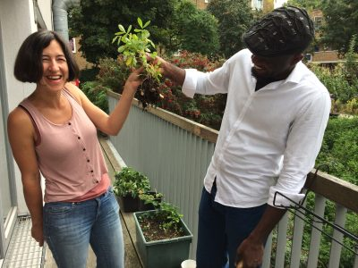

DISCUSSION
The familiarity of working with plants allows many members to reconnect with their past. In this year’s survey, people alluded to being reminded of ‘back home’ through working in the garden. These reminders can be profound and can stir deep emotions that involve all the senses and can be a powerful way to remember - and mourn - childhood and family and losses of homes and communities. It is through sharing the labour, the planning and harvesting, that people can also connect to each other and many alluded to the group aspect as facilitating, or unlocking the enjoyment and healing of gardening.

And for those who had not engaged in gardening or agriculture back home, it provided a chance to learn new skills and gain confidence, especially in deciding what to plant. Practical tasks with a meaningful, tangible value that are carried out together are inherently therapeutic.

APPENDIX II: CULPEPER GARDENING AND SOCIAL

100% of those who attended Culpeper this year found it positive [81% helpful; 14% OK; 0% found it unhelpful; 5% had not attended it]

“Some sense of belonging”

“It is good to be part of a community and sharing food, music together.”

“It's a good, relaxing occasion, joyful can have a nice meal.”

“Very good atmosphere more socials. This is a good for me to be able to socialise with other and have a good time.”
“Because I can spend time with other peoples that accept me as who I am.”
“it's my therapy place. Beautiful place, when you are stressed you can chat with people.”

“I like the fact that it is optional and given the choice and opportunity to meet familiar faces.”
“It depends on the weather or the people who are there.”

DISCUSSION
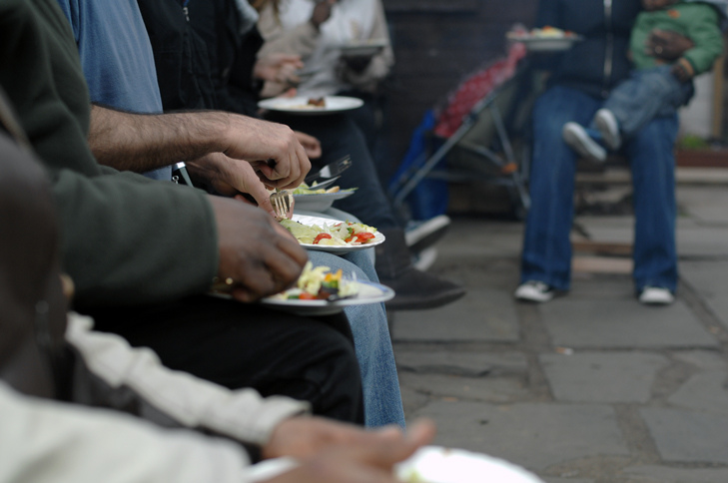
The food shared together on a Friday afternoon in the Culpeper Community Garden not only provides a focal point around which to chat, share laughter, exchange recipes and eat dishes from back home, and sample cuisine from other members’ home countries, but it is clear just how much social eating is linked to well-being. Again, members refer to being together and that this social, warm and open environment is like being with ‘family’, a comforting and enjoyable experience: “I like to sit around fire. Chatting and realise I have friends and some social life.”

It also gives the chance to socialise with members who do not attend Tuesdays or who have since ‘graduated’ from RtH: “Coming every Friday meeting people from the community who come not always from our group...more connection.” This is also very positive for staff and volunteers, a warm and open space that always feels welcoming.

APPENDIX III: COMMUNITY FORUM

- 74% felt they could participate in RtH decision-making [42% a lot; 16% often; 16% sometimes; 5% not much; 11% not at all; 11% not sure]

"It is a time to influence decision is have our say in how we things should be directed."

"The community forum is the place where you can talk about what you want to see happen."

"Because I they always want me to engage in everything like take part in interviewing new volunteers for room to heal."
"Yes I gave a suggestion to have baking class and they followed it"

- 94% of those who attended over 2017, found the Community Forum positive [50% found it useful; 30% OK; 5% not useful; 15% did not attend]

"They need to hear from people to know what they can to do more to make it better."
"I can say what I think and take on active part in what happens in my family."
"We need to support Room to Heal to make it stronger as they need to help us."

Explicit in the above responses is how much people value being a part of an active, dynamic community where their opinions are valued; rather than them being passive recipients of a service where decisions are made without consultation or transparency. Holding a group meeting like the community forum is one of the core tenets of therapeutic community practice: maximising the sharing of information and building a “sense of cohesion and togetherness within the community” where everyone can thus share in the hopes and fears of other members and in the day-to-day problems and achievements of the community. When activities actually do arise as a result of members’ suggestions, this can affirm agency and further self-confidence as well as validate the idea that positive change is possible

APPENDIX IV: THERAPEUTIC RETREATS

Over the course of the year, our members have benefited from 2 intensive therapeutic retreats. One at Abbey Farm in Cirencester and the other at Eden Rise in Devon.

100% enjoyed the retreats [86% very much; 14% quite a lot]

“I was feeling love by people, in other word I was feeling at home”

“I enjoy the quietness environment, the farm experience. It makes me to forget the struggles of London that I don't even think of the immigration issues. It took stress out of me.”

“I enjoy the family union. It make us to know more of ourselves, I was able to learn more about farming which has given me a dream.”

“It was good experience for me to be a this retreat. I really enjoyed every bit of it. I think I learn how to be with other people under the same roof. Thank you for everything.”

“I have had a very good time and my mind was relaxed without stress. I have had good housemates and it was nice to get to know them better.”

“I had a great experience of the retreat since it came at the right time when I was not well physically, emotionally and mentally. I was able to relax and clear my mind. What I got out of this retreat is that I am not alone, I will always have family with me.”

“I would like to go there again because that place bring me joy, beautiful countryside.”

100% felt better psychologically/emotionally at the end of the retreats [81% very much; 14% quite a lot; 5% a little]

“Eden Rise is a new place to my knowledge to the retreat; it was very exciting and eager to see, explore and new discovery. Despite the pains and aches, being in this environment changed my mental state.”

“It brings me my nostalgic moment when I was happy as a little girl and that happiness was so deep by seeing things that my father made for us, the plates the farm and all.”

“Because my brain was at rest and stress and worries was out of me. My mind was at peace.”

92% felt better physically at the end of the retreats [69% very much; 23% quite a lot; 8% not at all]

“My body feels refreshed. I feel more energetic.”

“By participating in all the outside activities like walking to the river, climbing hills to the seaside, and going to Dartmoor, it was challenging but I did it.”

DISCUSSION
Members expressed a desire to experience a different location and get to know other parts of the UK that they never get to see. So we decided to visit two new retreat locations.

Members were able to have a “break” where they could “breathe” and not have to dispel huge amounts of mental energy preparing for Home Office interviews, queuing to sign at the Home Office, or working out the cheapest way to get across London and buy food and essentials on the £5 per day that they receive as asylum support. The retreats provided welcome respite: “It makes me to forget the struggles of London that I don't even think of the immigration issues. It took stress out of me.”

Being somewhere where everyday challenges of survival are lifted: food provided, with no need to worry about transport, security or shopping, gives people some space to focus on the intense psychological and emotional work of meaningfully engaging in therapy, and of building relationships with peers. The therapeutic work could thus be fully and intensely engaged, indeed, the retreats have often been referred to as an “accelerated healing process” and at the core of this is the togetherness of sharing a space over a few days, cooking and eating together, walking, enjoying the countryside and creative activities/outings. This time to “bond” was very much appreciated, with members referring to the time as precious “family time”.

“What I got out of this retreat is that I am not alone, I will always have family with me.”

As a last word:

“There's nothing to say, all was adventurous and amazing. there was not time for conflict. all was together and everything was togetherness, happiness, helping each other! I cannot feel or think there's room to think about anything negative. All was glooming like sun beamers!!!!”

APPENDIX V: SHARING THE MODEL; TUNISIA AND THE GAMBIA

100% of respondents said they would be able to use the training methodology in their work
“We became more able to understand the mechanisms of how to facilitate the listening groups which will help us to develop services for victims of torture and abuse, in order to assist them in overcoming the sequelae of torture.”
“The training with Mr. Mark Fish and Ms. Rim ben Ismail on the facilitation of “listening circles” was fantastic.”

100% said the training met their professional/personal needs
“On a personal level, it gave us courage to open up freely in front of a group of people.”
“Thanks to this training, I really got to understand the term “secondary stress”, and as a result, I have learnt how to better confront this in my life - managing my time better at work and working in a more efficient way in order to limit and manage the impact of stress.”

“I feel that I have become more wise, that I can better control my own feelings and emotional reactions.”

“This training enabled me to make a deeper network of support with other psychologists being in the group with the same people each time is really important, especially as it reinforced our relationships with each other, but also deepened the reflection on the work and the services to beneficiaries and victims.”

“The development of discussion circles: it is very important to have the presence of a supervisor after these discussions, it is also important to have harmony and understanding between the two facilitators of the group.”

DISCUSSION
Since 2014, Room to Heal has piloted a training programme in Tunisia for psychologists, social workers and lawyers at OMCT (World Organisation Against Torture) working with people who have been subjected to arbitrary arrest and torture under the Tunisian emergency powers legislation. After the first year of this work, the Tunisian Ministry of Social Affairs seconded their psychologists to be part of this programme, and have been involved for two years. Since October 2017, the Tunisian Ministry of Justice and Psychologues du Monde have also been involved, and the training programme has reached psychologists working in the Tunisian prison system.
In this programme, we have supported the staff teams concerned in establishing and maintaining therapeutic support groups or “groupes de paroles”, such that they are able to work effectively with groups as opposed to working solely with individuals. We have achieved this aim by working with the various staff teams therapeutically (in much the same way as we would with a group of beneficiaries). This allows participants to gain first-hand experience of working in the group modality. This experiential training allows participants to come to understand the benefits and challenges of utilising group work as an effective way of working with survivors of torture and the complexity of issues they bring. Typically, the training sessions lasts between two and three days. In Tunis, we return for follow-up trainings every 6 months. This allows for a sense of continuity amongst staff members and much needed ongoing support and supervision of their work.
In March 2017, in recognition of the innovative nature of our community-oriented therapeutic model of working with survivors of torture, Room to Heal was invited to present our work at the second annual experts conference at the United Nations in Geneva. Shortly after the conference, the UN asked Room to Heal to provide training and support to the Prison Fellowship in The Gambia. We were able to complete a successful training on similar lines to the above and are looking forward to continuing this work in 2018.
Working in groups is good for survivors of torture because it allows bonds of kinship and solidarity to develop – and this sense of belonging and fellowship (and the renewed meaning in life that it creates) does much to aid recovery. It is also good for people who work with survivors of torture, who have to constantly address the terrible and horrific traumatic events that survivors carry with them. The group modality of working allows staff teams to bond at a deeper level together, creating an environment of trust, where the often difficult and stressful realities of working with survivors of torture, can be properly negotiated. In particular, and of great importance, it also allows staff teams to acknowledge and address issues of vicarious trauma (the traumatic impacts and effects of working with traumatised people) such that they can develop strategies to cope with and manage such impacts more effectively.

APPENDIX VI: ROOM TO HEAL’S AIMS

Our Mission: To support people who have survived torture and human rights abuse to rebuild their lives in exile through an integrated, community-based programme of therapeutic and casework assistance.

AIMS & OBJECTIVES

1) To enable people to heal from their traumatic experiences through:
Reduced anxiety, depression and post-traumatic symptoms; Increased ability to articulate traumatic history; Development of trust and belonging; Increased sense of wellbeing, hope and meaning in life.

2) To assist people in dealing with material challenges through:
Increased knowledge of and ability to access legal, welfare, housing, health services; Increased confidence in navigating asylum process; Greater access to education, voluntary work and employment training.

3) To enable local communities, policy makers, service providers and the general public to respond more appropriately to the needs of refugees and asylum seekers:
Local communities, policy makers, mainstream service providers and the general public demonstrate greater understanding of the needs of survivors of torture and organised violence; Policy and practice are better suited to meeting the needs of survivors of torture and human rights abuses.

AIMS | ACTIVITIES/ OUTPUTS  The following activities will help us to achieve this aim: | OUTCOMES  The following changes in our members will enable us to measure our success:
1. To enable people to heal from their traumatic experiences | - Therapeutic groups;  - Therapeutic and social gardening sessions;  - Physical therapies;  - Creative activities & workshops;  - Intensive therapeutic & skills retreats. | - Instillation of hope and meaning in life;  - Reduced isolation;  - Development of trust and a sense of belonging  - Reduction of anxiety, depression and related post traumatic symptoms;  - Increased ability to articulate traumatic history.
2. To assist people in dealing with material challenges | - Casework sessions (to address legal, housing, health and welfare issues);  - Interventions in support of asylum and other material needs;  - Education and employment advice sessions. | - Increased knowledge of and ability to access/receive support from relevant services (legal, welfare, housing, health);  - Increased awareness of rights and entitlements;  - Increased confidence in navigating asylum process;  - Greater knowledge of and ability to access education, voluntary work and employment training.
3. To enable local communities, policy makers, service providers and the general public to respond more appropriately to the needs of refugees and asylum seekers | - Storytelling workshops, performances, attendance at conferences to influence public perceptions on migration;  - Knowledge-sharing platforms, forums, peer support and training;  - Articulating and communicating our unique model and reaching a wider client-base. | - Local communities, policy makers, mainstream service providers and the general public have a greater understanding of the needs of survivors of torture and organised violence;  - Policy and practice are better suited to meet the needs of survivors of torture and organised violence.

We continue to apply the following Theory of Change to monitor and evaluate RtH’s performance:
“If we enable survivors of torture and organised violence to heal from their traumatic experiences, reduce their isolation and help them to address material life challenges, particularly in the context of the asylum process, then we will have improved their quality of life and helped them rebuild their lives. This is because survivors of torture, living in exile in the UK, typically experience severe deficits in these areas.”

APPENDIX VII: ACTIVITIES IN 2017

Activity | Description | No of Beneficiaries
Assessments for New Referrals and Individual Psychotherapy | Relational and trauma-focussed psychotherapy prior to joining the therapeutic support group, or to members in crisis. | 651 referral meetings, assessment sessions and individual therapy sessions for 54 individuals
Therapeutic Support Group | Two weekly mixed-gender therapeutic support groups. | 98 therapeutic support groups (2 groups, 49 weeks) for 23 members
Casework Sessions | Practical support for individuals relating to accessing legal, welfare, health and housing services. | 2010 casework sessions for 53 members
Legal Protection Work | Assisting members in accessing appropriate legal support, articulating trauma and gaining legal protection | 53 members
Intensive Rural Therapeutic & Skills Retreats | 2 intensive therapeutic retreats for members to the countryside. | 11 members
Therapeutic Gardening & Food-Growing Programme | Weekly gardening group at Mildmay Community Centre, run by a senior psychotherapist and gardening coordinator. | 40 members
Culpeper Community Garden | Weekly gardening and cooking social in the Culpeper Community garden. | 50 members
Storytelling Workshops & Performances | Storytelling at the RtH 10th Anniversary Summer Party | 7 members to a total of 150 audience members
Community Forums | Open forum for the RtH community, held quarterly | 4 forums attended by 21 members

REFERENCES
Bendfeldt-Zachrisson, F. ‘State (political) torture: Some general, psychological and particular aspects’. International Journal of Health Services, 15:339-349, 1985.
Caruth, C (ed.) (1995) Trauma: Explorations in Memory (Baltimore and London: John Hopkins University Press)
Caruth, C. (1996) Unclaimed Experience: Trauma, Narrative, and History (Baltimore and London: John Hopkins University Press)
De Leon, G. (2000) The Therapeutic Community: Theory, Model and Method (New York, Springer Publishing Company) 119
Foa, E. & Rothbaum, B. (1998) Treating the Trauma of Rape: Cognitive-Behavioural Therapy for PTSD (New York: Guildford Press)
Freedom From Torture (July 2013) The Poverty Barrier: The Right to Rehabilitation for Survivors of Torture in the UK
Gorman, W. (2001) Refugee Survivors of Torture: Trauma and Treatment, Professional Psychology: Research and Practice, 32(5) pp. 443-451

Kennard, D. (1998) An Introduction to Therapeutic Communities (Jessica Kingsley Publishers, London and Philadelphia)

Kira, I., Ahmed, A., Mahmoud, V. & Wassim, F. (2010) Group therapy model for refugee and torture survivors, Torture Journal 20 (2)

Mollica (1988), ‘The trauma story: The psychiatric care of refugee survivors of violence and torture’, in F. Ochberg (ed.), Post-traumatic therapy and victims of violence (New York, Brunner/ Mazel)
Ryan, D., Dooley, B. & Benson, C. (2008) Theoretical Perspectives on Post-Migration Adaptation and Psychological Well-Being among Refugees: Towards a Resource-Based Model Journal of Refugee Studies, 21 (1)
Turner, W. & Gorst-Unsworth, C. (1993) Psychological Sequelae of Torture, Medical Foundation for the Care of Victims of Torture
Van der Kolk, B (2014) The Body Keeps the Score: Mind, Brain and Body in the Transformation of Trauma (London, Penguin)

Instead of service user of client, we refer to RtH members: conferring agency and belonging.
Bendfeldt-Zachrisson, F. ‘State (political) torture: Some general, psychological and particular aspects’. International Journal of Health Services, 15:339-349, 1985.
Turner, W. & Gorst-Unsworth, C. (1993) p.16
Turner, W. & Gorst-Unsworth, C. (1993) p.8
Gorman, W. (2001) Ibid. p.446
Turner, W. & Gorst-Unsworth, C. (1993) p.9
De Leon, G. (2000) The Therapeutic Community: Theory, Model and Method (New York, Springer Publishing Company) p.119
Van der Kolk, B (2014) The Body Keeps the Score: Mind, Brain and Body in the Transformation of Trauma (London, Penguin)
Caruth, C (1996) Unclaimed Experience: Trauma, Narrative, and History (Baltimore and London: John Hopkins University Press)
Mollica (1988), ‘The trauma story: The psychiatric care of refugee survivors of violence and torture’, in F. Ochberg (ed.), Post-traumatic therapy and victims of violence (New York, Brunner/ Mazel) p.312
Ryan, D., Dooley, B. & Benson, C. (2008) Theoretical Perspectives on Post-Migration Adaptation and Psychological Well-Being among Refugees: Towards a Resource-Based Model Journal of Refugee Studies, 21 (1)
Freedom From Torture (July 2013) The Poverty Barrier: The Right to Rehabilitation for Survivors of Torture in the UK p 79
See Appendix V for the outreach and training work in Tunisia and The Gambia.
http://www.unhcr.org/uk/news/stories/2017/10/59eda4e24/garden-helps-refugees-put-down-roots-in-britain.html
Kennard, D. (1998) An Introduction to Therapeutic Communities, (Jessica Kingsley Publishers, London and Philadelphia) p.24

